*Updated on June 21, 2023*

# **Welcome to the Funding Metrics Form!**

The **Funding Metrics Form User Guide** provides instructions on how to successfully submit the funding metrics form, confirm the submission, and make any necessary edits to the funding metrics through the Collaborating Organization (CO) portal. It offers step-by-step guidance on the entire process, ensuring that you can efficiently navigate the system and fulfill the required funding metrics documentation.

***If you encounter any issues or have any questions, please submit a ticket using the following form: https://support.aws.amazon.com/#/contacts/aws-restart***

Contents

**Welcome to the Funding Metrics Form!** 1

**Instructions** 2

How to Submit **‘Funding Metrics Form’** 2

How to Verify **‘Funding Metrics Form’** Submission 4

How to Edit **‘Funding Metrics Form’** Submission 6

Appendix A: Definitions of Funding Metrics Form fields 10

# **Instructions**

## How to Submit **‘Funding Metrics Form’**

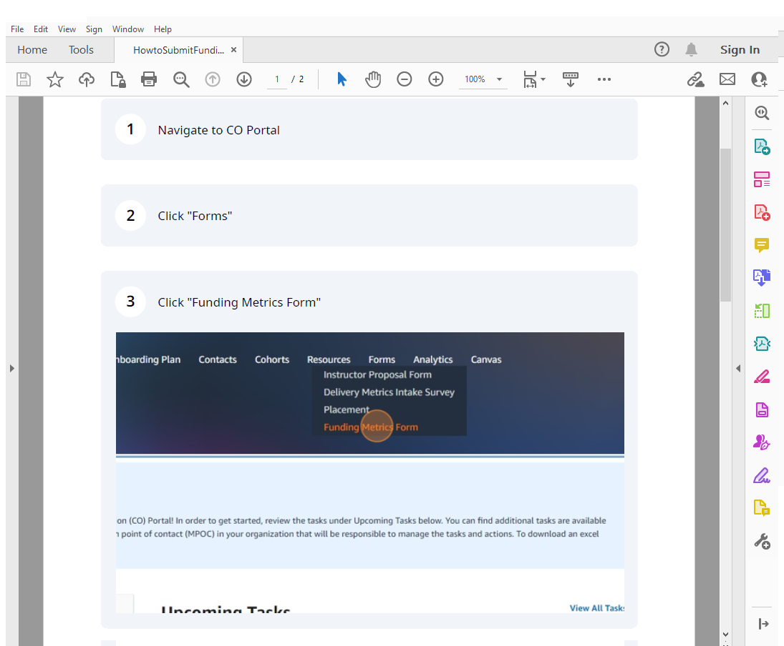

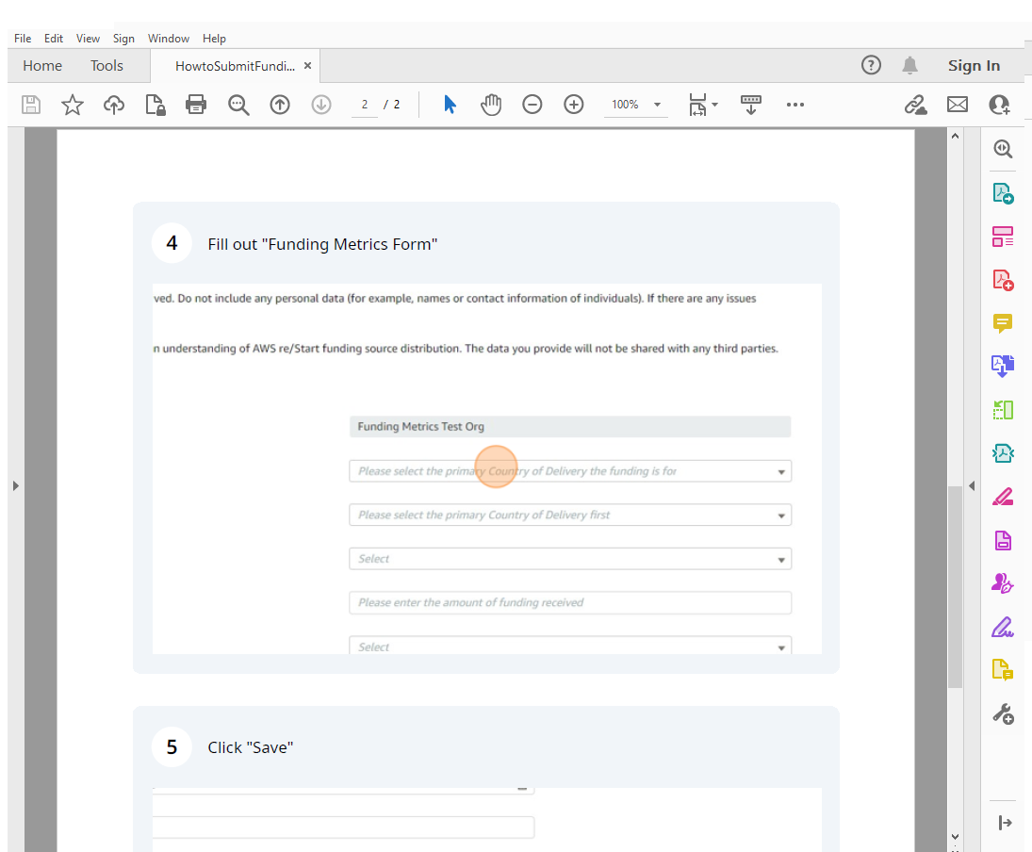

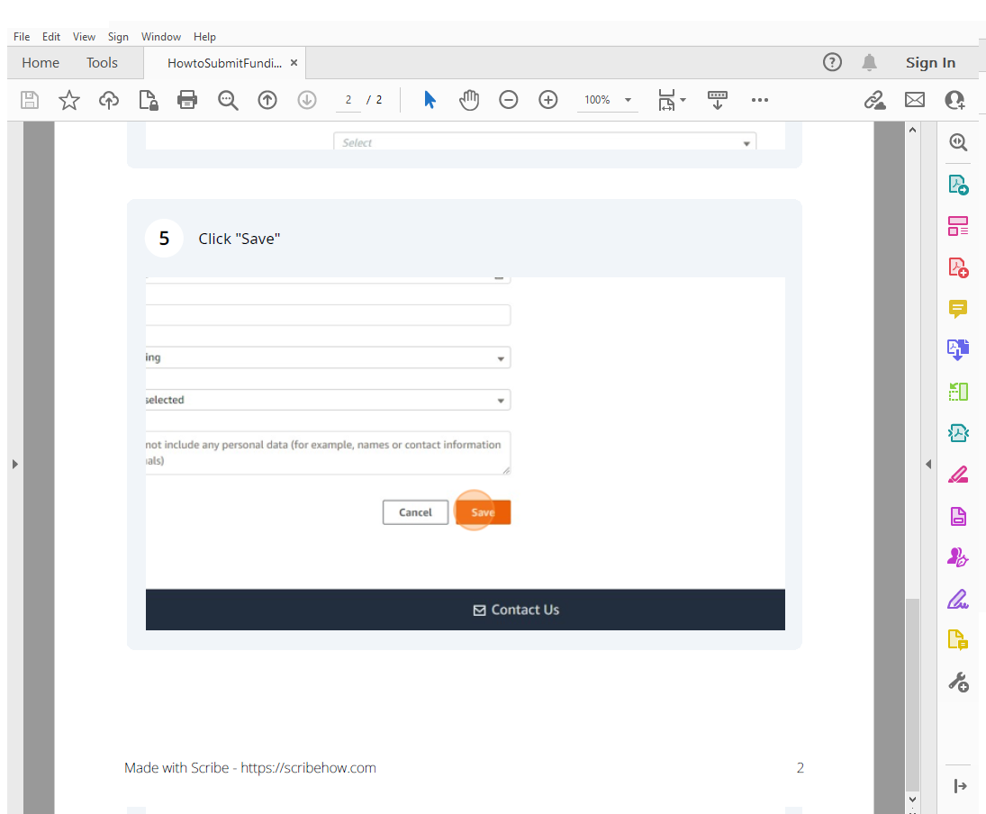

*See* ***Appendix A*** *for definitions of Funding Metrics Form fields*

## How to Verify **‘Funding Metrics Form’** Submission

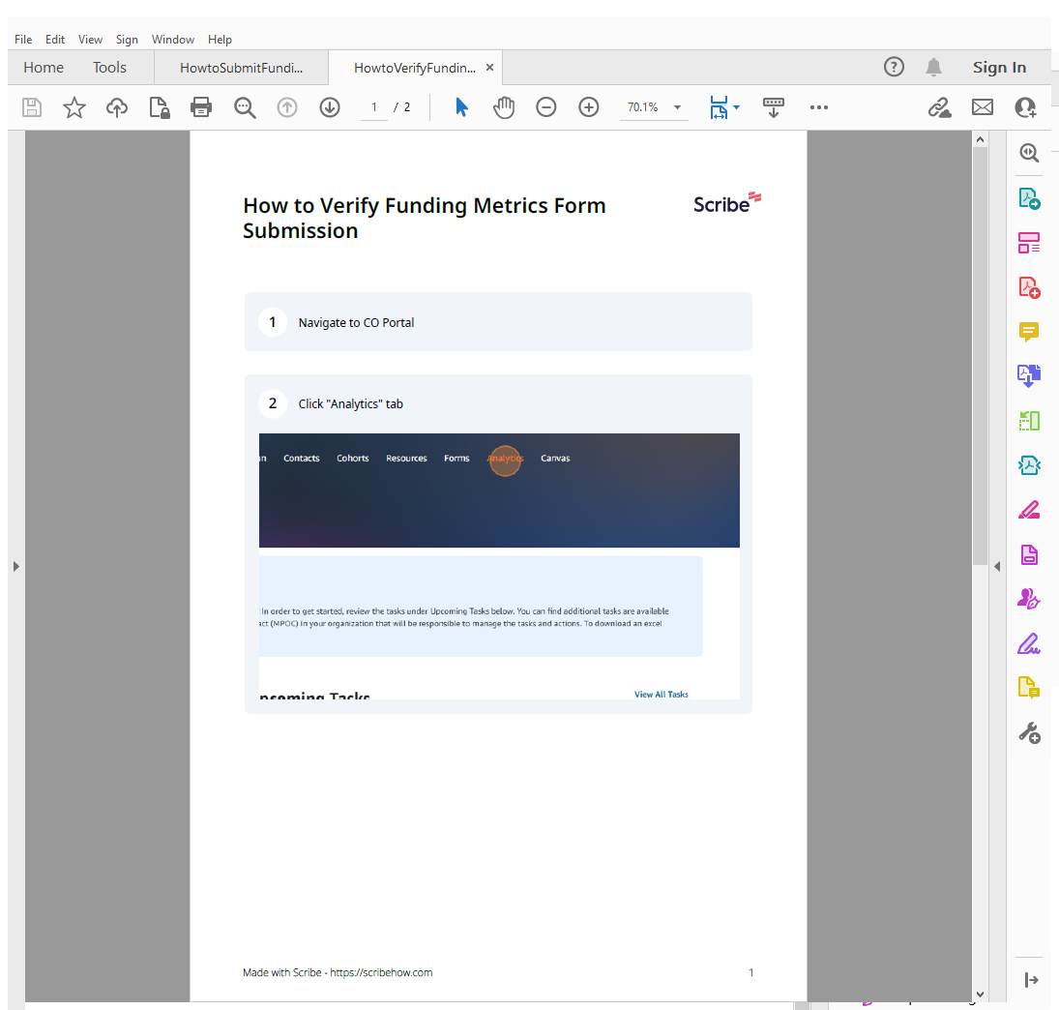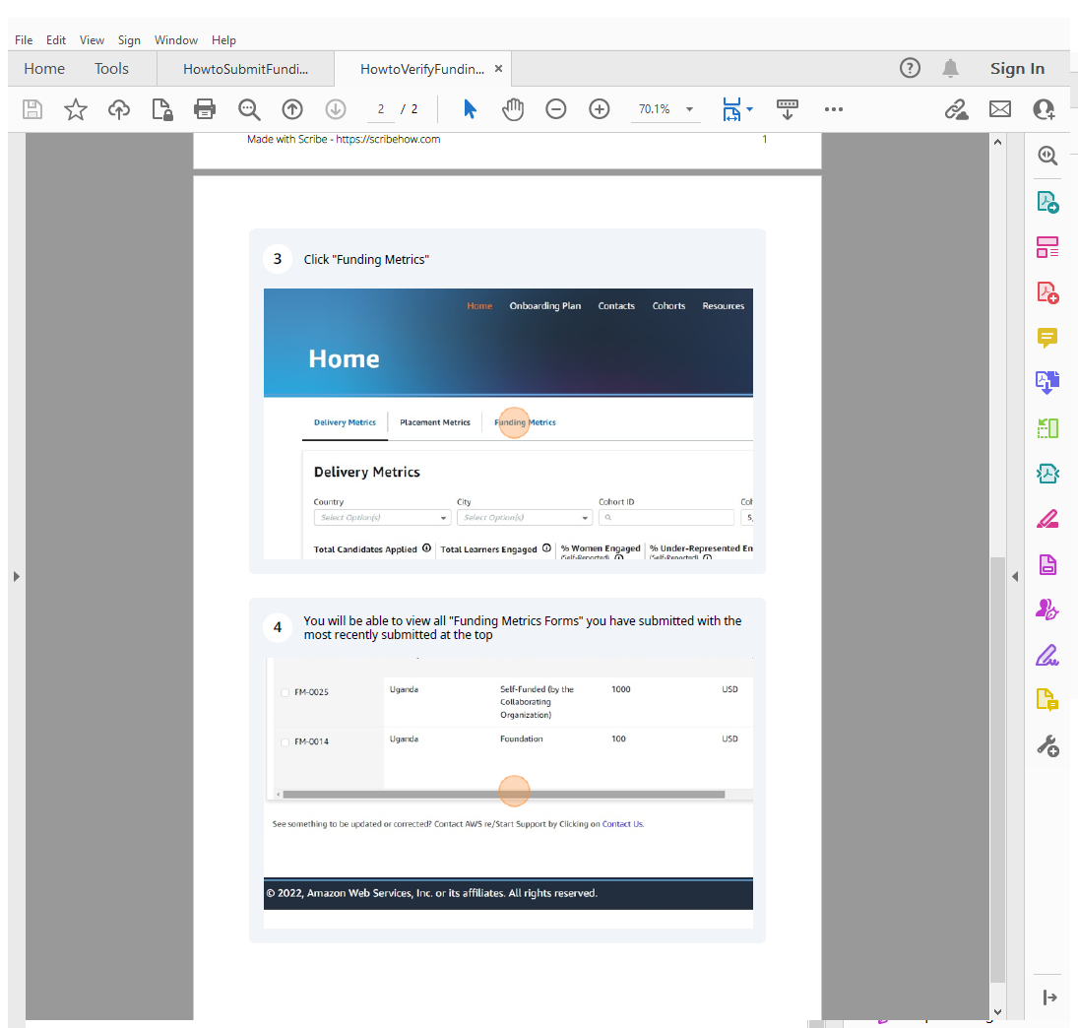



## How to Edit **‘Funding Metrics Form’** Submission



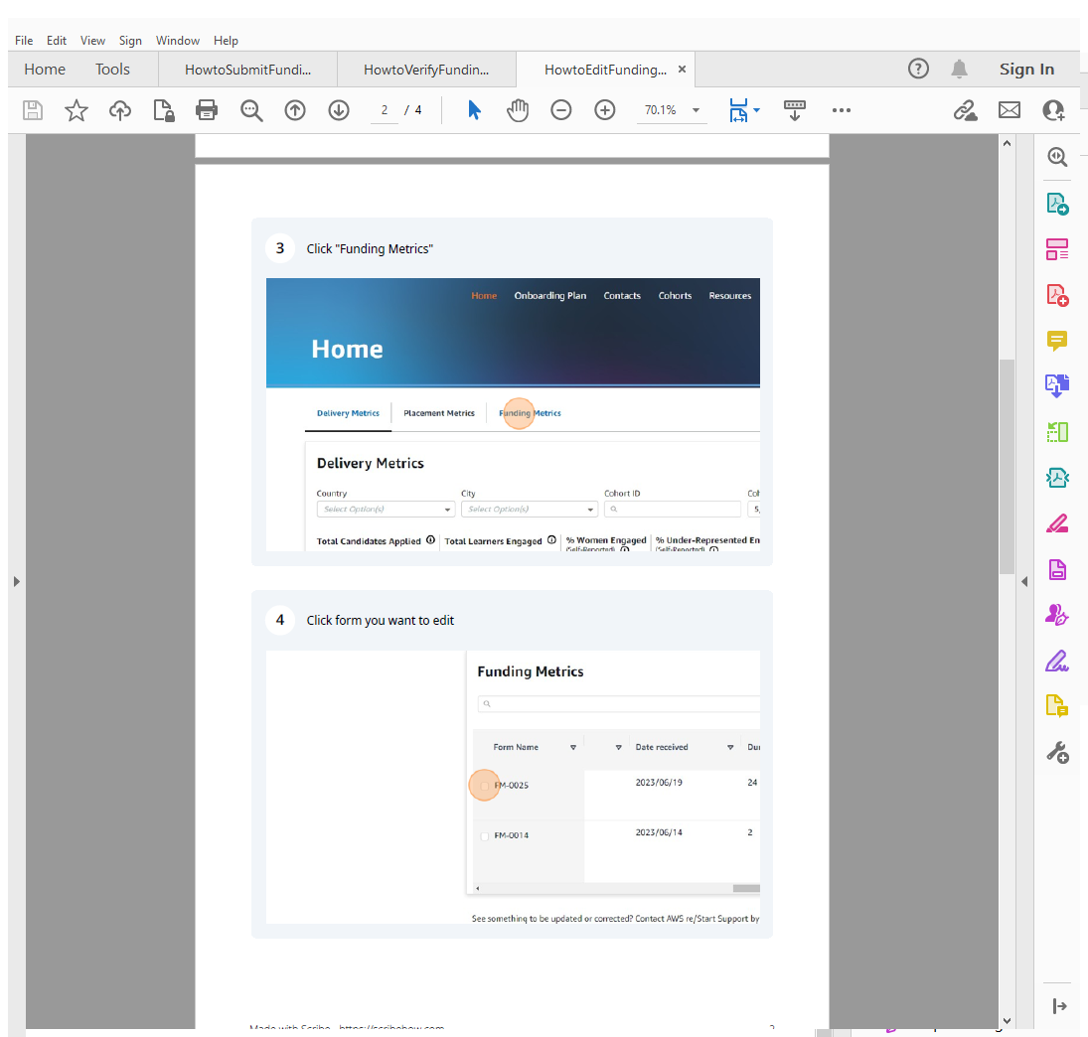

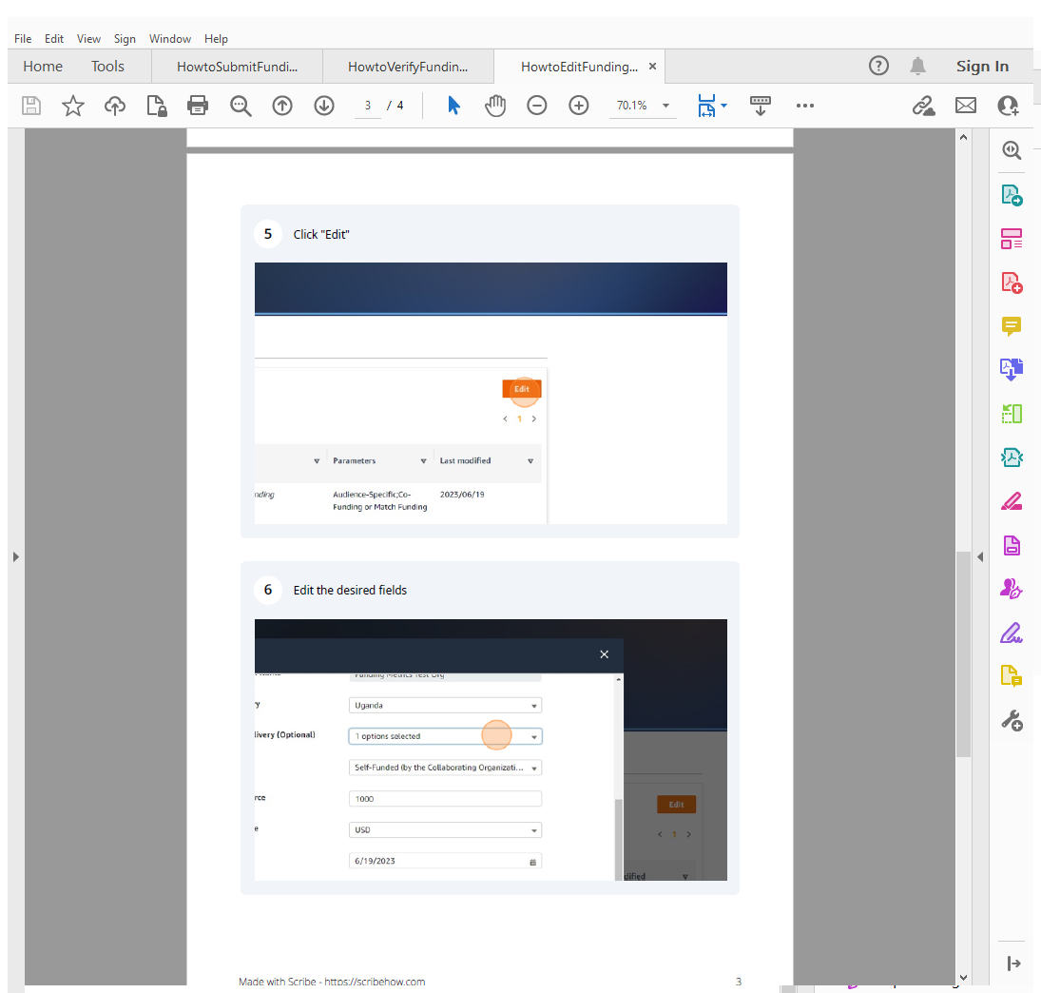

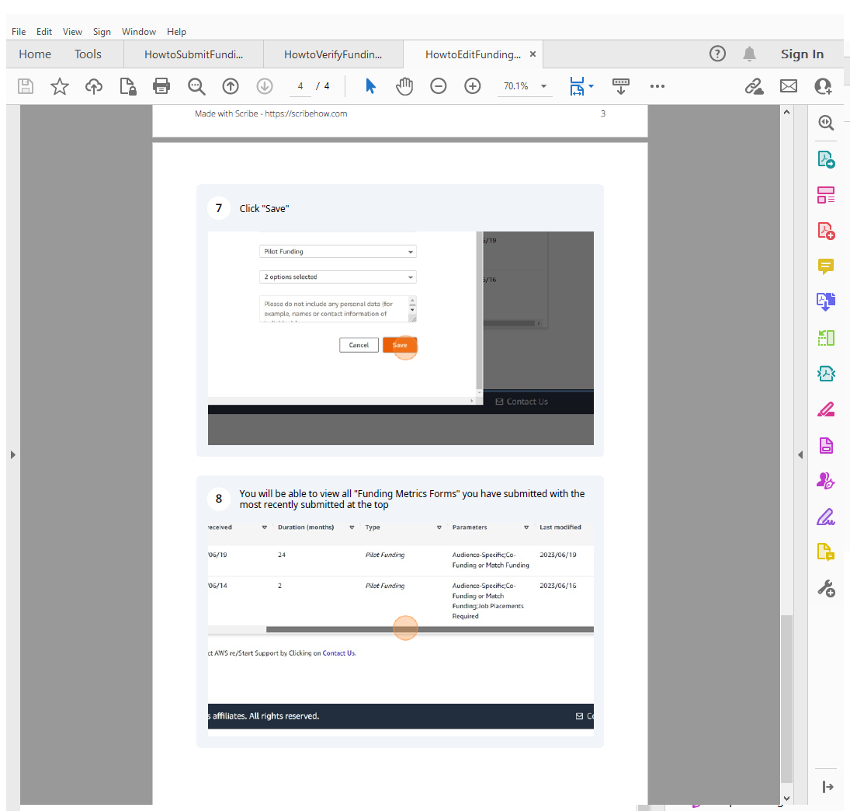



## Appendix A: Definitions of Funding Metrics Form fields

|  |  |  |  |
| --- | --- | --- | --- |
| Field Name | Description | Instructions | Comments |
| *Collaborating Organization Name* | Collaborating organization name associated with login of person filling out form. | No action required | If one collaborating organization has received the funding, and the funding is supporting an additional collaborating organization, please make a note of this in the “Notes” section |
| *Country of Delivery* | Here you will see a list of countries associated with the collaborating organization. | Please select the primary Country of Delivery the funding is for |  |
| *Will this be used in any other Country of Delivery?* | Use this field if the funding will be used in multiple countries. | Please select all other Country of Delivery this funding will be used for |  |
| *Type of Funding Source* | You will see the following options:   * Foundation * Multi-National (e.g. United Nations) * Central Government (e.g. National) * Self-Funded (by the Collaborating Organization) * Corporate Sponsorship (e.g. Corporate Gift) * Regional (e.g. Province, State, County) * Local (e.g. Municipal, Council, City) | Please select one type of funding source that best fits the gift. If you are reporting multiple funding sources, please fill out the form once for each. | Foundation (for example, an award of a private grant from a non-governmental organization to the collaborating organization towards AWS re/Start)  Multi-National (for example, contribution from the United Nations or other multi-national body to the collaborating organization towards AWS re/Start)  Central Government (for example, contribution from a national government at the country level towards AWS re/Start)  Self-Funded (by the collaborating organization towards AWS re/Start)  Corporate Sponsorship (for example, contribution from a corporation to the collaborating organization towards AWS re/Start)  Regional (for example, contribution from the provinc, state, or county government towards AWS re/Start)  Local (for example, contribution from the council or city government towards AWS re/Start) |
| *Amount from Funding Source* | Amount | Please enter the amount of funding received |  |
| *Currency of Funding Source* | Currency | Please select the currency of the funding received |  |
| *Date Funding Received* | Calendar Drop Down | Please select the date the funding has or will be received |  |
| *Duration of Funding* | Number of Months | Please enter the number of months the funding was awarded for |  |
| *Type of Funding* | You will see the following options:   * One-Time Funding * Pilot Funding * Recurring Funding | Please select one type of funding | One-Time Funding (all of the funding matching the funding description is captured in this form)  Pilot Funding (funding awarded that may lead to additional funding if the initial funding has successful outcomes)  Recurring Funding (this form captures funding that will be recurring, with each amount of the recurring funding to be captured in separate form entry) |
| *Funding Parameters* | You will see the following options:   * Audience-Specific * Co-Funding or Match Funding * Job Placements Required * Location * Other * None | Please select all the applicable funding parameters |  |
| *Notes* | Enter text here regarding funder details, cohort IDs receiving funding, and/or any othe information pertinent to the funding award. | Please do not include any personal data (for example, names or contact information of individuals). |  |